**Gap Identification and Reporting**

**Name: Muhammad Faraz**

**Business Analyst Internship**



**State: Dawai.pk**

**Current State**

**Company Overview:**

Dawaai.pk is a pharmacy-led healthcare group focused on delivering authentic medicines to customers’ doorsteps. They emphasize quality and convenience by employing qualified pharmacists and maintaining high standards in procurement, storage, and delivery.

**Customer Interaction:**

Dawaai.pk offers customer service through qualified pharmacists who are available from 09:00 AM to 09:00 PM, Monday to Saturday. They are accessible via phone calls.

**Ensuring Authenticity:**\*

Dawaai.pk procures medicines directly from manufacturers or their distributors, maintaining constant communication and quality control mechanisms to ensure the authenticity of their products.

**Convenience:**

Dawaai.pk provides doorstep delivery by trained riders under safe and hygienic conditions, ensuring medicines are delivered in sealed packages. Customers can inspect the package before acceptance but cannot return or exchange medicines once accepted.

**Target State**

**Company Overview:**

Dawaai.pk aims to expand its services by enhancing customer satisfaction, broadening the range of services offered, and utilizing digital tools to improve accessibility and efficiency.

**Customer Interaction:**

The target state includes extending customer service hours to 24/7 availability and implementing multiple channels of communication, including online chat support and mobile app integration, to provide faster and more accessible support.

**Ensuring Authenticity:**

Dawaai.pk plans to implement advanced tracking systems for medicines, allowing customers to verify authenticity through QR codes or an app-based verification system.

**Convenience:**

The target state involves reducing delivery times through optimized logistics and offering more flexible delivery options, such as same-day or express delivery, while maintaining the current standards of safety and hygiene.

**Identified Gaps**

**1**. **Customer Service Availability:**

1. **Current State:** Customer service is available only from 09:00 AM to 09:00 PM, Monday to Saturday.
2. **Target State:** 24/7 availability of customer support.
3. **Gap:** Limited hours of operation could lead to customer dissatisfaction, especially during emergencies outside business hours.

**2**. **Communication Channels:**

1. **Current State:** Customer interaction is primarily through phone calls.
2. **Target State:** Multiple channels, including online chat and mobile app support.
3. **Gap:** Limited communication channels restrict customer accessibility and may delay response times.

**3. Delivery Efficiency:**

1. **Current State:** Medicines are delivered to the doorstep, but the delivery time is not specified.
2. **Target State:** Optimized logistics for faster delivery, including same-day or express options.
3. **Gap:** Potential delays in delivery might not meet the urgent needs of some customers.

**Suggested Improvements**

**Extend Customer Service Hours:**

Implement 24/7 customer support to cater to customer needs at any time, especially in emergencies. This can be achieved by introducing shifts or AI-powered chatbots to handle after-hours queries.

**Enhance Communication Channels:**

Develop a mobile app and integrate online chat support on the website to provide multiple avenues for customer interaction. This will ensure quicker response times and improve overall customer satisfaction.

**Optimize Delivery Processes:**

Invest in a logistics optimization tool to streamline delivery routes and reduce delivery times. Offering express and same-day delivery options will further enhance the convenience factor, ensuring customers receive their medicines promptly when needed.

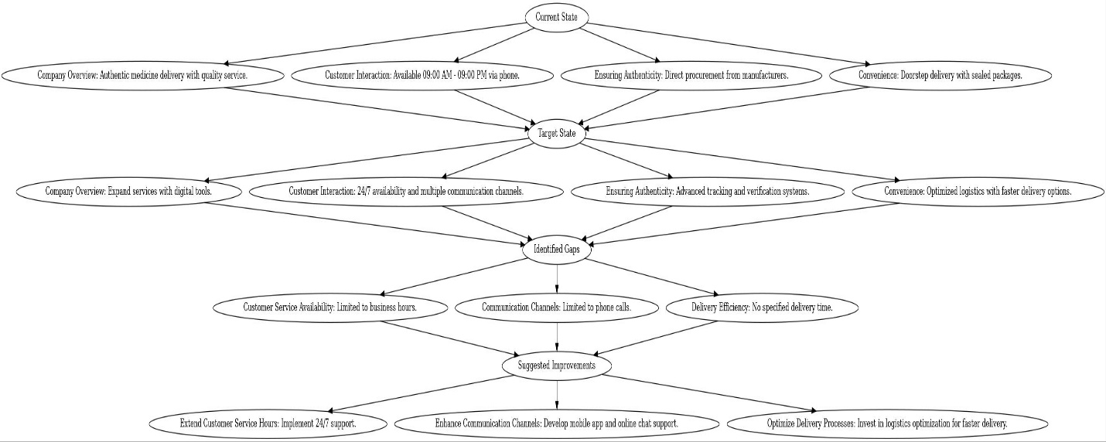**FLOWCHART**